**Property Analysis BI Developer- Standard Sprint - Part 4**

**Task 20**

**Using Existing KeysDW, Build Monthly Property financial report on PowerBI- rental income vs expense**

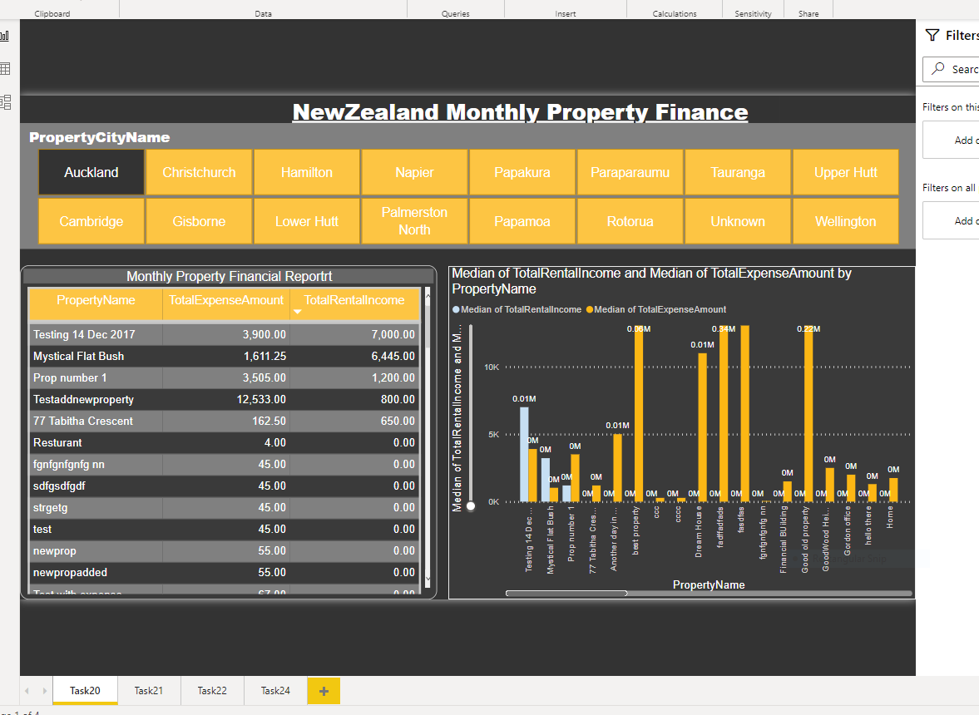

**Task21**

**Using Existing KeysDW, Line chart of Property Value Changes in the suburb of 1,5 and 10 years on DW**

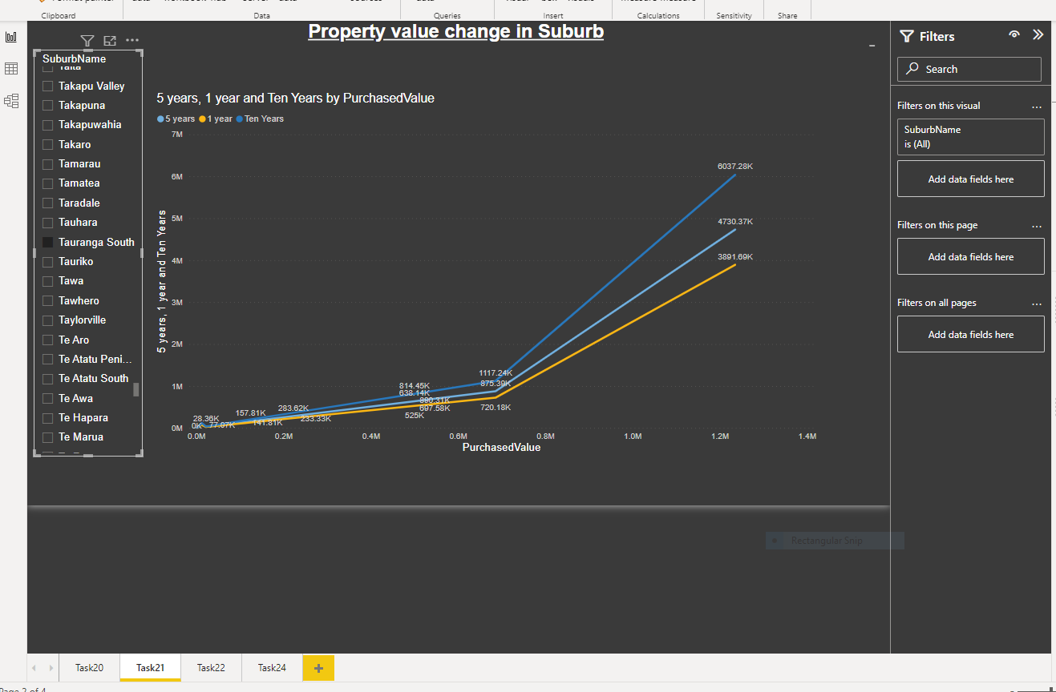

**Task22**

**Using Existing KeysDW, Build Pie chart of all expenses categories on DW**

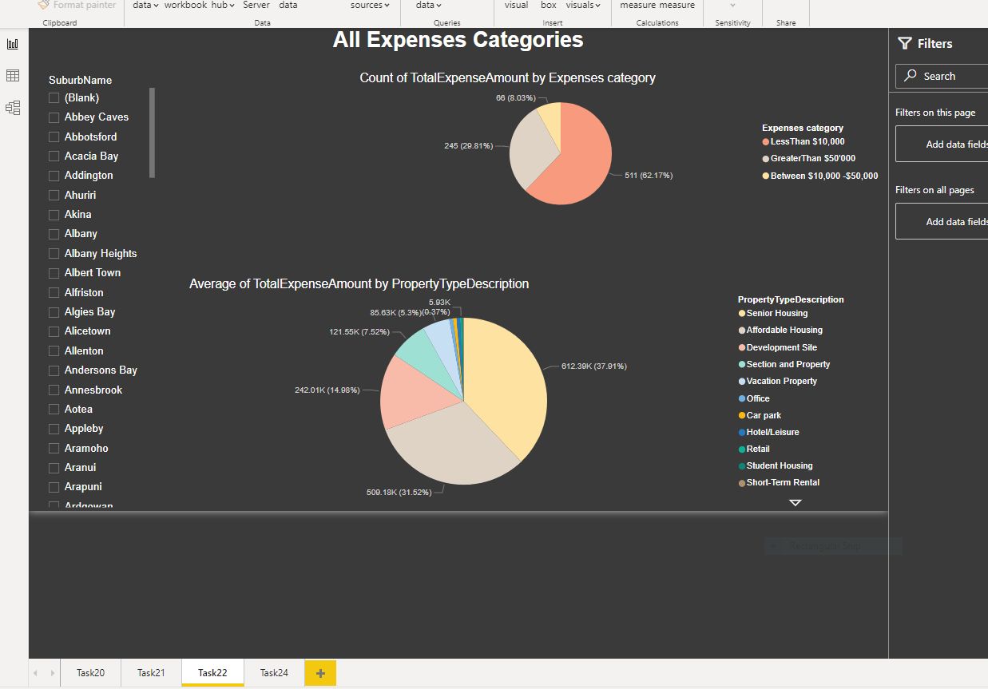

**Task24**

**Using Existing KeysDW, Build Custom map display Public transport within 1km radius of given input property**

